
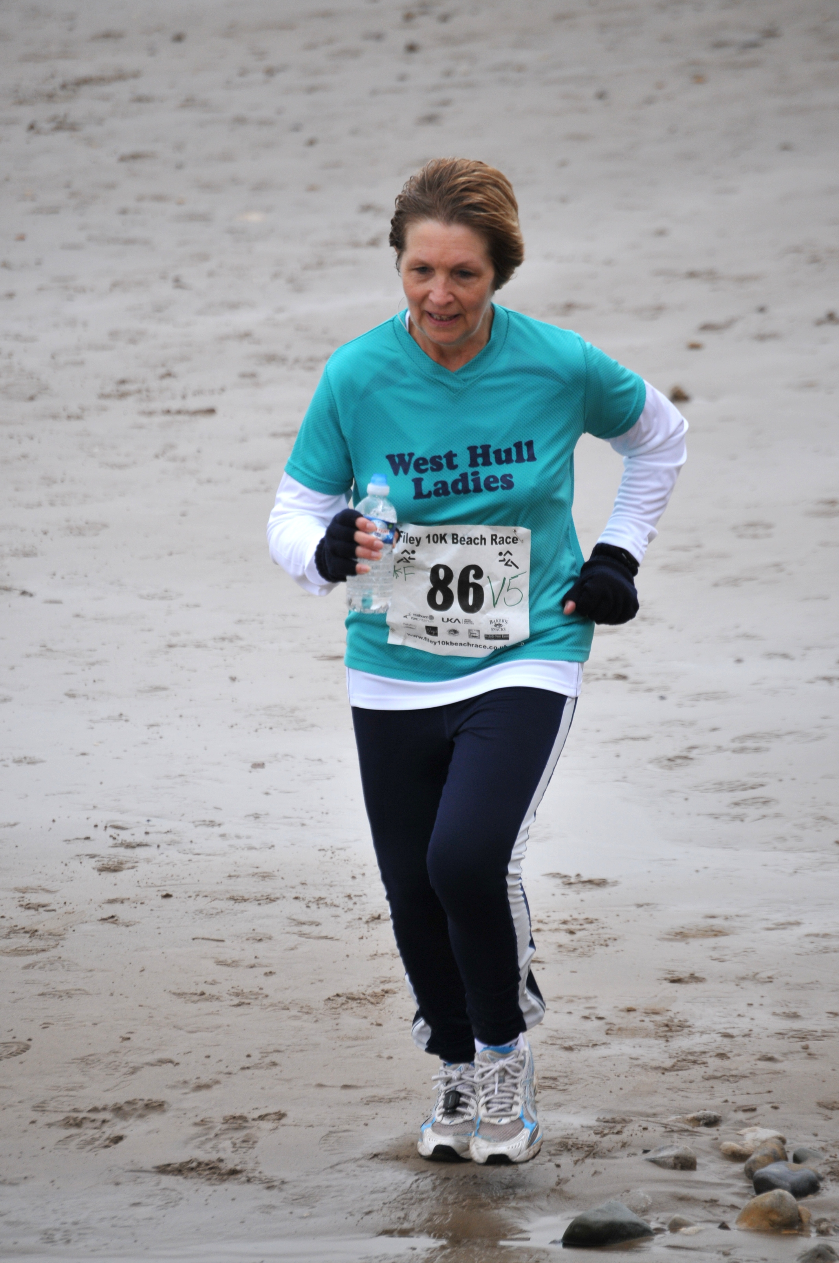
KarenC in the Filey 10K Beach Run

West Hull Ladies R.R.C Committee Meeting

Monday 4th October 2010

Attendees: - Rebecca King, Karen Scott, Katy Snow, Jo Townsend, Debbie Watson, Amanda Dean, Louise Ede, Rachael Laughton and Victoria Voase.

Apologies: - Annette Pearson

- London Marathon Club Places
It was confirmed that LE would be applying for our Club Places by 20 November 2010. We would create a new letterhead based on the font used on our jackets. It seems that we will get 2 places. The draw will take place, however, on the basis that the first name drawn will definitely get a place and the second name drawn will get a place only when it is confirmed that a place in available. LE confirmed she was unclear regarding the number of votes the club holds at its areas AGM. LE confirmed that she will make some enquiries.
It was agreed that the London Marathon draw would take place on Monday 11th October 2010 and AD would circulate an e-mail reminding ladies in this regard.
KarenS confirmed that she has a place for Brighton Marathon which can be deferred to another runner.

- UKA Membership Numbers
VV will e-mail LE details.

- Club Jackets and T-shirts
There are now jackets available to purchase. There were some ladies who enquired about a t-shirt but there is a minimum order of five. VV will double check with Geri regarding what sizes we currently have and what sizes we need to order.

- EYCC
It was unclear what was actually being suggested and therefore we would need to revert back to the e-mail received from City of Hull. It seems that some ladies may be interested in the cross country season runs in the winter.

- Beep Test
The venue cannot be booked until the students leave. AD will therefore book the next session on 20th December 2010.

- Vacant Racing Officer Role
Verity Pick has agreed to take over from KS. RK will arrange for the folder to be handed over.

- Pasco’s Meal
Thanks were offered to Debbie and Annette for organising the meal.

- Training Officer’s Report
AD will e-mail to enquire regarding 3XTRI. The Brass Monkey will take place on 23rd January 2011 and the entries are online only. The Rudolf Romp entry is also now available. The results of races will be included on our website under a separate page.

- Events Officer’s Report
It was agreed that the Christmas Run will take place on 22nd December 2010 with mulled wine and muffins afterwards.

Muscle of the Month; Soleus

Where is it? It attaches to the front aspect of the tibia and fibula (the two bones in the lower leg) and then goes down the back of the leg to form an important tendon – the Achilles tendon.

What is it? It is part of the group of muscles at the back of the leg known as triceps surae, along with gastrocnemius and the Achilles tendon.

What does it do? Soleus is a plantarflexor of the ankle joint, which means that it allows us to point our toes. Soleus, along with gastrocnemius, are powerful muscles and are vital in activities such as walking, running and dancing. Soleus particularly plays an important role in standing; if not for its constant pull, the body would fall forward.

Also, in upright posture, it is responsible for pumping venous blood back into the heart from the periphery, and is often called the skeletal-muscle pump, peripheral heart or the sural (tricipital) pump.
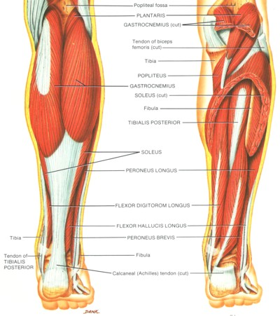
How does it get injured? This muscle can get chronically tight and shortened through overuse, through wearing high heels and, particularly, through not stretching after exercise. When stretching, always ensure that this muscle is sufficiently warmed up.

How can soleus injuries be treated? People tend to think only of the larger gastrocnemius muscle when dealing with calf injuries, but soleus can also get injured and generally through overuse. As well as pain in the outside of the calf, soleus injuries can also be felt at the front, close to the shin bone. I treat soleus injuries through deep tissue massage.

How do I stretch it? The best stretch for this muscle is the same as for gastrocnemius. Stand with the front part of your foot on a stair and drop one heel down to stretch the calf. Hold the stretch for 30 seconds then repeat on the other side. To stretch the bottom part of this muscle, bend the knee of the leg you are stretching and lean forward slightly. This will take the stretch down towards the tendon insertion.

How do I strengthen it? Heel raises either at the gym or on a step or stair strengthen this muscle.

Which muscle groups are related to it? Gastrocnemius is very closely related to this muscle, by virtue of its function and proximity.
Quick anatomy fact: Soleus has a higher proportion of “slow twitch muscle” fibres than many other muscles. In some animals, such as the guinea pig and cat, soleus consists of 100% slow muscle fibres. Human soleus fibre composition is quite variable, containing between 60 and 100% slow fibres.
About me
I am an Advanced Remedial Massage and Manipulative therapist based in Cottingham, Hull and Beverley. I treat a variety of sports people in my clinics and I am always delighted to treat members of the West Hull Ladies running club so if you would like to book an appointment or have any questions, you can email me at kirstieannskelton@hotmail.com, call 07789 914597 or visit my website www.kirstieannskelton.com for further details.

Marathon News

Congratulations to Sharon who was the first out of the hat for a club London Marathon place!
Congratulations to Gill who was second!
Louise is backup if either of them have to drop out before registering their entry.
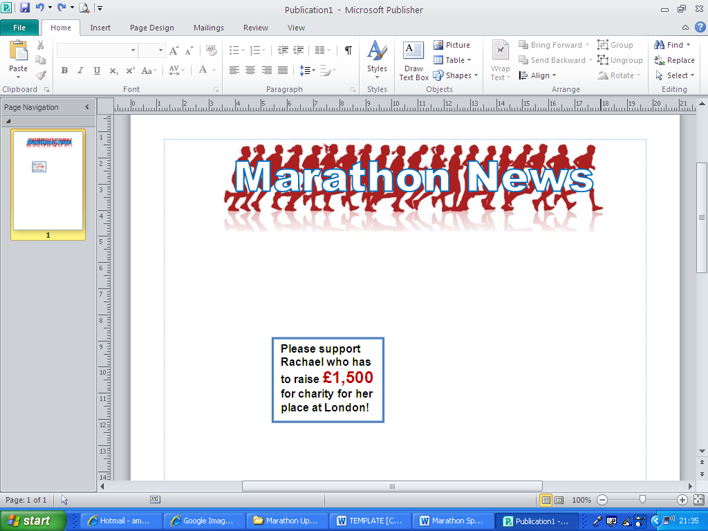
We have eleven West Hull Ladies running marathons in 2011 which is fantastic! Keep us posted if there’s any more to add to this page:
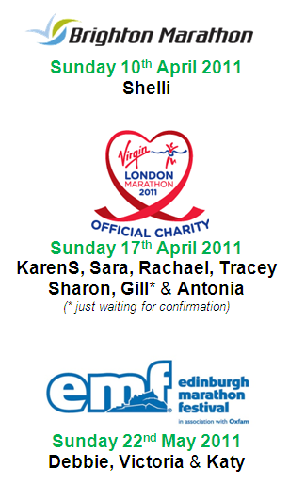

Running: A race against gender
Forwarded by Antonia

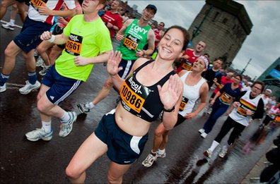

Lucy Proctor on the 13-mile run
Can men and women ever compete fairly in a sport like running? Yes, but it requires a little bit of maths know-how. "What time did you get?" It is the first question runners ask of each other when the race is over. But is it the right question?
You see, distance running is unfair.
Men experience this unfairness as they get older. Ten miles into a half-marathon, older men can only struggle on with growing irritation as younger men - men who would not have stood a chance against them in their prime - sail past.
For women, the feeling of injustice comes as soon as we start racing.
Men have bigger hearts and can take in and move around oxygen much more efficiently than women can. So men can beat us even if we are "better" runners. So is it possible to adjust for age and sex to level the playing field?
To solve this maths problem I challenged my 52-year-old colleague David Lewis to race against me, a 28-year-old woman, in the Great North Run half-marathon.
Then I went in search of a statistician.
Alan Jones, a retired IBM engineer, is the ultimate number-crunching runner. For decades, he has worked on this very problem for World Masters Athletics (WMA) - the international association for veteran athletes.
Another running enthusiast and statistician, Howard Grubb, has used Alan's figures to create the excellent age-grading calculator now featured on the Runner's World website.
It is painstaking work. Alan plots the best time ever attained at each age and for both sexes over all the commonly run distances, using data from many competitions. He then plots them on a graph - one graph for each distance.
Alan then draws a curve just underneath the times. By comparing points on the curve to the world record time for the 10 kilometres and marathon races, he is able to work out an age-factor.
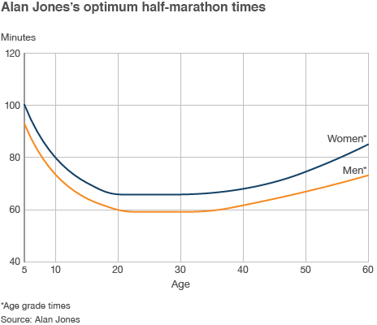
By multiplying any time at any distance by the correct age-factor and turning the new time into a percentage of the fastest time possible, we get the performance score - how good a given time is compared to the best.

For example, if I get a time of one hour 40 mins, I first turn it into seconds - 6,000. Using Alan's tables, I can see the age-factor for my age of 28 is 1 - because I am too young to yet have one. So I just divide the top possible time for that distance by a woman - 3950 seconds - by 6,000 to see how I compare, and I get a performance score of 65.8%.
If David did the same time, he would look to Alan's tables and see he has an age factor of 0.8693. He multiplies his 6,000 seconds by that age factor, and gets 5215.8 seconds. By dividing the top possible time for that distance by a man - 3553 seconds - by 5215.8, he gets a performance score of 68.1%.
As women are only compared with other women, and men with other men, the performance percentage automatically adjusts for sex.
Alan's numbers give us the secret to a fair race. For example: if you compare the best possible time for men and women over a half marathon you get a factor of 0.8995. The age-factor for a 48-year-old man is also 0.8995.
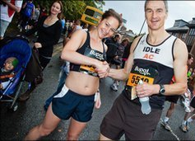
So a young woman (younger than 30) can race against a 48-year-old male happy in the knowledge that it is a fair contest.
"Of course, it is fair anyway," says Alan. "If he runs faster than you, he runs faster than you. That's the nature of a race."
I chose to ignore that bit, as David and I made our way to Newcastle.
So, who won?
Alan's tables throw up an interesting Great North Run fact. Because he uses times for the marathon and 10km races to plot the half-marathon times, he has shown that the current female half-marathon world record set by Lornah Kiplagat in 2007 - one hour, six minutes and 25 seconds - is short of what should be possible.

How did they do?
- Half marathon - 13.1 miles
- Great North Run 2010 winning time: Haile GebreSelassie 00:59:33 (37-years-old)
- Haile's performance score: 101.26%
- David's finishing time: 1:40:23
- Lucy's finishing time: 1:37:19
- David's performance score: 67.86%
- Lucy's performance score: 67.65%
His tables show a best possible time of 1:05:39. The fastest time ever run by a woman at half marathon was by our very own Paula Radcliffe, in the Great North Run, in 2003. She achieved 1:05:40- but, sadly, the Great North Run isn't recognised as a world record course.
Using Alan's tables and working backwards, I calculated out that if David and I were both to finish between one hour 30 minutes and one hour 40 minutes, I would have to beat him by at least three-and-a-half minutes just to get an equal percentage score of 68%. By 52, it seems, age is a greater handicap than sex.
In the end I finished exactly three minutes earlier than David. So according to Alan Jones, David beat me by 30 seconds.
But forget fairness. I still crossed the line first.

Race Write-Ups or Write-Offs
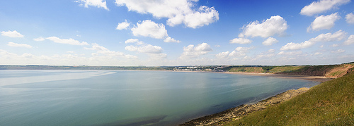
Filey 10k Beach Race, Sunday 26th September 2010

KarenC: I don't usually give a write up for the races I enter as each one would say more or less the same thing "it was hard". However I thought as I have never attempted a beach run before that I should give some feedback.

Well what can I say? When I arrived at Filey it was freezing cold, gale force winds and really not very nice at all. Everyone was milling around trying to get out of the wind. At this point I was wondering what on earth had possessed me to enter in the first place!!

The race got off to a good start - a good downhill section to start with to get us on to the beach. It was a back wind and my first 3 miles were under 30 minutes so I knew the wind was helping me. I plodded along (as usual) to the half way mark and water station, where we turned around to run the second half of the race and what a shock that was - the wind hit me and it was a head wind all the way back to the finish, with gusts of up to 30/35 miles an hour. Not only did I have the wind to deal with but then the rain started as well and at one point it was difficult to even see where I was going. Apparently the weather this year was better than last year as well so glad I didn't decide to do it for the first time last year.

I kept going but struggled with the force of the wind and rain. I finally reached the last stretch - an almighty hill climb - it was steep!!!! and my legs by this time were aching, but I got to the top and managed the last few hundred metres round the headland to the finish.

I haven't managed to find the results as yet but think I did about 71 minutes, which under the circumstances and the weather conditions I don't think is too bad for me. I feel like I have really achieved something today, never having run a race on the beach before and I wasn't last!!!

I would definitely do this race again, but hope the weather is a bit better next time, and the little cafe is great for a nice warm cuppa at the end.

Bridlington Half Marathon, Sunday 17th October 2010
Amanda: Boy what a bad race; you can use this as a lesson in how not to run a half marathon.
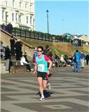
I had set my sights on something close to 90 minutes which was a bit optimistic since it’s a hilly route. My training plan lasted the first mile then I slowed as we headed uphill towards Flamborough Head and finally gave up on ‘close to 90 mins’ and aimed at a PB (94 mins). I had a nice bit of running from about 3 miles to 4.5miles but then realised that was because I had dropped into the comfort zone and was cruising gently along. So, metaphorically kicking my own ass, I tried harder and persuaded myself that my strength would kick in once we turned inland at Bempton. Unfortunately we turned into a headwind and uphill which continued to about 7.5 miles. When we finally headed down with the wind rattling my right ear, I ran faster by pushing hard but it was hurting and now and, not only did I give up on a PB, I planned on giving up racing for life!
The downhill finished after a couple of miles and after turning it was pretty flat with a backwind which was finally helpful. I concentrated on keeping my form and not giving in to the ranting in my head which was quite insistently telling me I should walk.
Despite this, 11M came and me and my head turned into Sewerby Gardens but, as we came out on cliff top and the final run to the beach, the headwind slapped me in the face. My remaining plan was to keep ahead of other ladies ..... at which point two very young Bingley Harrier girls bounced past me and my final plan hit the deck.
But I still had a bit of spirit left as a couple of ladies caught me and I tucked in then waited for the drop down to the promenade and whizzed past them (I’m good at downhills) legs staggering about as I hit the flat, but I propelled them on and hung on and hung on and hung on and finally, after what felt like an eternity, reached the finish in 98 mins.
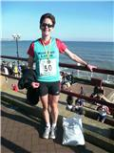
I was quite amused with my own lack of judgement of my current capabilities ... chucking in 1 week with a lot of miles, a bit of speed work the following week and relying on some training I did two months ago, then hoping I could pull it out of the bag on the day really does not work.. However, I felt a lot better when I received the 1st female vet 50 prize, £25 in cash but, a PB is much sweeter.
And am I giving up racing? .... hope to see you on Sunday at Haltemprice. Glutton for punishment eh?


Run to the Beat Half Marathon, London.
Sunday 25th September 2010
Geri: Hi guys just a quick note to say that myself and Katy completed our first half marathon in London on Sunday. I found it quite difficult but managed to keep my pace up. Finished the race in 2hrs 11mins which I was a smidgen disappointed with - wanted to go for the 2. But hey look at me what an achievement met a new friend as well, Lauren from Brighton, who has added me on Facebook. Although I didn’t manage to run with Katy I’m very proud of her as I wouldn’t have kept up the running without her. We did manage to find each other at the end though. Would I do it again it was a no straight after, but now a maybe. xx

Katy: Oh my god! The tube was cancelled on the way to the race which was the first disaster. Then I was pushed into a pen which contained faster runners so I was not impressed! I got to mile 7 and stopped to gather my thoughts, and then I was passed by an angel and a guy dressed as a boob! I lost the will to live at mile 10 and slowly made it back to the finish. For anyone that runs with me, they will know that I have a beetroot face after the first mile, and when I crossed the line I was as white as a sheet. Not sure if the antibiotics I was taking for my wisdom tooth was anything to do with it! I wanted to do it in less than 2.30 and my time was 2.30, gutted!!! X

Isle of Axholme Half Marathon,

Sunday 3rd October 2010

Annette: I fancied doing a half marathon this year to try to improve on my time from the Great North Run last year (2:08) and maybe even try for under 2 hours. I had intended to do Major Stone but with it not being on this year I had to find another. I must admit that I didn't really fancy the prospect of a stormy sea breeze in Mablethorpe so James and I plumped for Isle of Axholme in Epworth near Doncaster, hoping that one further in land would be more comfortable.
On the morning of the race we woke to torrential rain and strong winds. We battled the weather to get to Epworth and parked in the field designated as the car park. The race organisers had laid on taxis to take us to the start (and back at the end) and there was a bag drop in the Youth club. Fortunately the rain had dropped to a slight drizzle as we began to run but this continued for the rest of the time, although I can usually cope with a bit of rain. The race began at 11am, an hour later than Mablethorpe, and while I was waiting I felt sorry for those already running in the rain and wind.
The course was very pleasant and rural but not as flat as we were led to believe. We ran alongside many fields and it was very picturesque. On a dry and gentle day it would be a great course and I suspect a reasonably fast one. I started with a few 8 minute 30 miles which gradually slowed to about 9:15 at mile 9-10. I reckoned I would probably just manage to go under the 2 hour mark, only just, but it was a possibility. However, then the real wind kicked in. From 10 miles we were running into a strong wind along flat fields with no trees or any sort of buffer. At about 12 miles I was praying for houses, both for the end to be in sight and for some sort of built up area to block the wind. At 12.5 miles there was a hill, which most definitely was not welcome at this stage. By now my mile time was down to about 10 minutes 45 seconds and all hope of a sub 2 hours was gone.

As I finally got back into Epworth and down to the final corner James was at the side of the road calling me in (having himself finished in 76 minutes). I crossed the line in 2:03:52, slower than I'd hoped but faster than last year so still a reasonably good achievement for me. Overall the organisation was fantastic and despite the rain and wind it was an enjoyable race. I would even venture to say that I would do it again next year which I don't often say about races.

NOTE: Club Vests must be worn at any races you enter
under the West Hull Ladies running club name.

CLUBWEAR PRICES:
Vest | £15.00 | All items are ordered on request and must  be paid for at time of ordering. To place an  order please get in touch via West  Hull Ladies e-mail and mark your emails  for the attention of Geri.
T- shirt | £16.50
Hoodie | £14.00
Jacket | £32

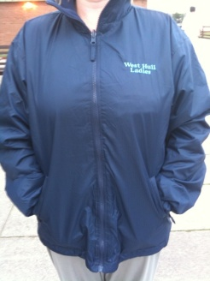

New Club Jacket available in three sizes: small, extra small, and junior (large fitting). If you would like to purchase one please send a cheque for £32 to Victoria Voase, Treasurer, and state on the back of your cheque your name and that the cheque is for a jacket.

Becca

Running Library

Using the library - Locker 18.
Choose your book, write your name and date on the card and leave the card in the locker so we know where the book is.
Book List:
- The Runner's Diet (Runners World), Madelyn H. Fernstrom
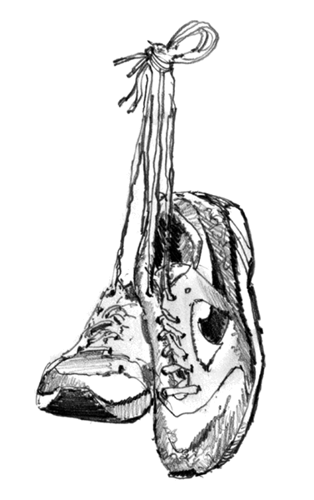
- Paula My Story So Far, Paula Radcliffe
- Running Made Easy, Susie Whalley
- The Complete Book of Running for Women, Claire Kowalchik
- Absolute Beginner's Guide to Half Marathon Training, Heather Hedrick
- Run Fast: How To Beat Your Best Times Every Time, Hal Higdon
- The Runner's Handbook, Bob Glover
- The Competitive Runner's Handbook, Bob Glover & Shelly Lynn Glover
- Marathon: From Start To Finish, Sam Murphy
- Marathon Running For Mortals, John Bingham
- Four Months to a Four-Hour Marathon, Dave Kuehls
- Marathon Running Beginner to Elite, Richard Nerurka

Running Magazines: These are available to borrow from the table in the club room.

